Faddeeva function

Alias

Faddeeva function

Kramp function

Def

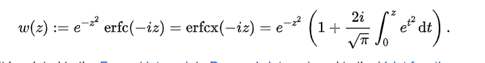

Property

$$w\left(x+iy\right)$$

= $$V\left(x,y\right)+iL\left(x,y\right)$$

where

$$V\left(x,y\right)$$ denotes real Voigt functions.

$$L\left(x,y\right)$$ denotes imaginary functions.

$$w\left(z\right)$$

= $$2e^{−z^{2}}−w\left(z\right)$$

$$w\left(−z\right)$$

= $$conj\left(w\left(conj\left(z\right)\right)\right)$$

$$w\left(iz\right)$$

= $$erfcx\left(z\right)$$

= $$e^{z^{2}}⋅erfc\left(z\right)$$

$$w\left(z\right)$$

= $$\frac{i}{pi\left(\right)}⋅integral\left(\frac{e^{−t^{2}}}{z−t}dt,t=−inf,t=\inf{}\right)$$

where

$$Im\left(z\right)>0$$

Derivative

The derivative of Faddeeva function is

$$\frac{d}{dz}w\left(z\right)$$

= $$\frac{2i}{pi{\left(\right)}^{\frac{1}{2}}}−2⋅z⋅w\left(z\right)$$

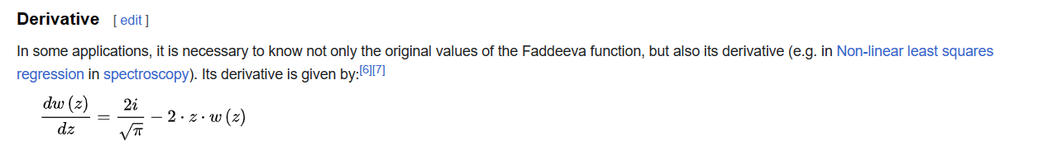

Ref

[Faddeeva function - Wikipedia](https://en.wikipedia.org/wiki/Faddeeva_function)